

**Adama Science and Technology University**

**School of Electrical Engineering and Computing**

**Course Title:**Electronic Circuit I

**Course Number:**ECE2101

**Lab:** Experiment Number 4

**Title:**Clipper and Clamper Circuits

**Prepared by:**

**Name ID No.**

**Submitted to: Lecturer Zewdu**

Date of conduction: December 15, 2016

Date of submission: December 22, 2016

**Acknowledgement**

We would like to acknowledge our lab assistantfor his support and explanation in the laboratory. Through the group work and experiment we were able to comprehend the topics that were raised and able to communicate with each other well.

**Theoretical Background**

Clippers are networks that employ diodes to “clip” away a portion of an input signal without distorting the remaining part of the applied waveform. There are two general categories of clippers: series and parallel. The series configuration is defined as one where the diode is in series with the load, whereas the parallel variety has the diode in a branch parallel to the load.

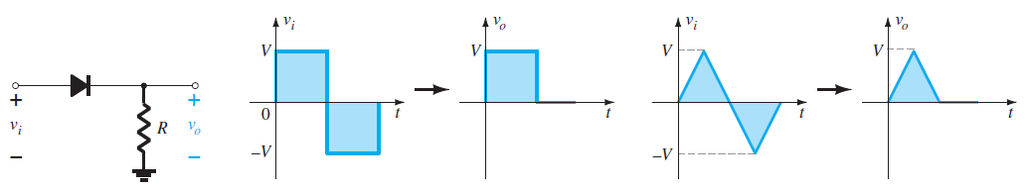

***Figure 1: Series Clipper***

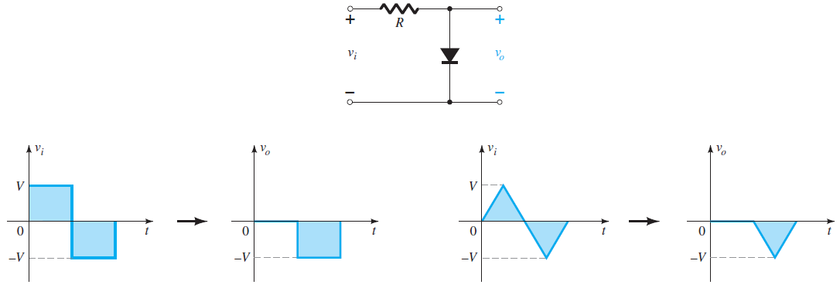

***Figure 2: Parallel Clipper***

The ability of a clipper circuit to clip off a positive and a negative section is determined by the magnitude of the dc supplies.

A clamper is a network constructed of a diode, a resistor, and a capacitor that shifts a waveform to a different dc level without changing the appearance of the applied signal. Additional shifts can also be obtained by introducing a dc supply to the basic structure. Clamping networks have a capacitor connected directly from input to output with a resistive element in parallel with the output signal. The diode is also in parallel with the output signal but may or may not have a series dc supply as an added element.

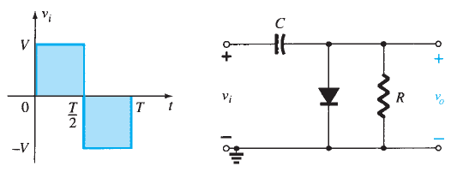

***Figure 3: Clamper Circuits***

**Lab – 4: Clipper and Clamper Circuits**

**Objectives:**

* To analyze the action of clipper and clamper Circuits.

**Apparatus Used:**

* DC power supply

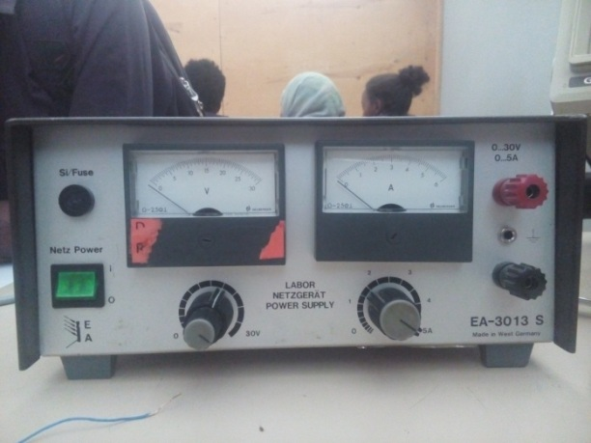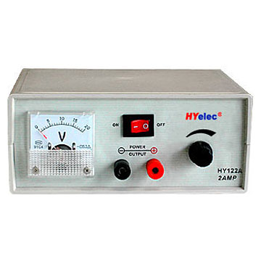

* Variable AC power supply
* Digital Multimeter (DMM)

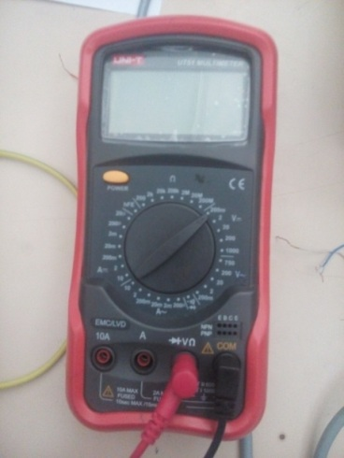****

* Resistors:1k $Ω$

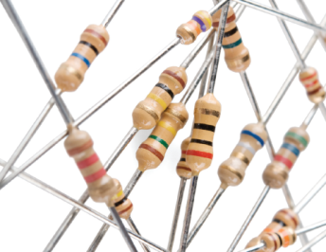

* Diode: Silicon (1N4007)
* Breadboard

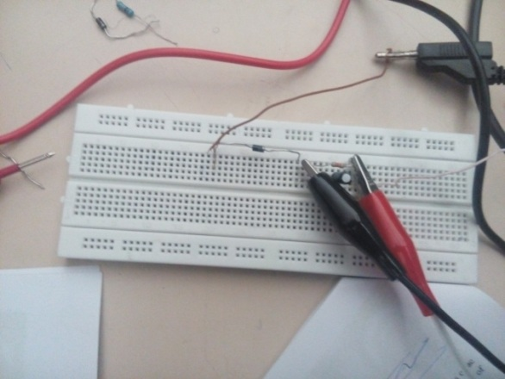

* Oscilloscope

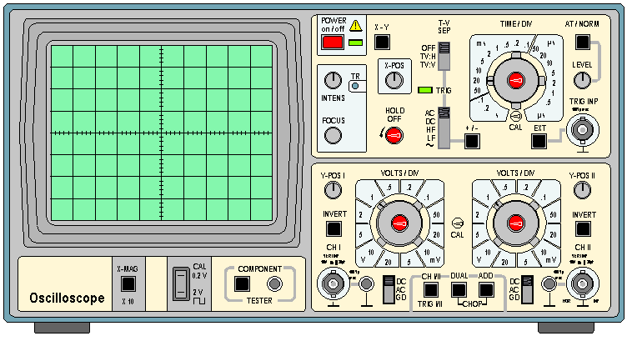

* Connecting Wires
* Electrolytic Capacitors

**Procedures**

**Clipper Circuit**

1. First of all we placed our components and instruments on a fine surface to begin our experiment.
2. Thereafter we constructed a circuit on the breadboard where the AC source is in series with the resistor and then the diode is in series with the resistor. Following the diode DC source is in series which then finishes with the AC source being in series with the DC source.
3. Then we set the DC source to 2V and the peak to peak voltage of the AC source to 10V. Also here we set the frequency to 1 KHz.

Figure 4: Negative Clipper

1. Then by placing the probes of the oscilloscope at the two ends of the diode we observed the output wave form.
2. Then we measured and recorded the DC and AC level of the output using a digital Multimeter.
3. Finally we repeated all the above procedures when our diode is reversed. Meaning for the positive clipper circuit.

Figure 5: Positive Clipper

**Clamper Circuit**

1. First of all we placed our components and instruments on a fine surface to begin our experiment.
2. And we constructed a circuit containing a capacitor, a diode and an AC source. This clamper was designed as a negative clamper.

Figure 6: Negative Clamper

1. Thereafter we set the peak to peak Voltage of the AC source to 10V. And we set the frequency to 1 kHz.
2. Then we connected the oscilloscope to the circuit and observed the output wave form.
3. Finally we repeated all the above steps to a positive clamper which we obtained by reversing the diode.

Figure 7: Positive Clamper

**Result and Discussion**

After conducting our experiments we have obtained the following output wave-forms.

Figure 8: Positive Clipper

Figure 9: Negative Clipper

Figure 10: Positive Clamper

Figure 11: Negative Clamper

**Questions**

1. Design a clipper circuit to remove a voltage level greater than 2V and less then -2V of a sinusoidal input signal with a peak value of 5V.
2. Design a clamper circuit to add a DC value of 3V to a sinusoidal input of peak value 5V.

**Observations and Conclusion**

We have observed the following points:

* The clipper Circuit cuts out part of a wave form displaying the output we wanted to see from the input wave form. The part of the wave form to be cut depends up on the direction of the diode, the available sources and the way the diode is connected to the resistor (series or parallel).
* The clamper circuit does not bring any change to the input wave form. Rather it moves (shifts) it by the value we determined it to in the circuit. The shifting of the circuits depends up on the direction of the diode, and the available sources.

**References**

* Electronic devices and circuit Theory 11th edition, R. L. Boylestad and L. Nashelsky



**Thank you!!!**